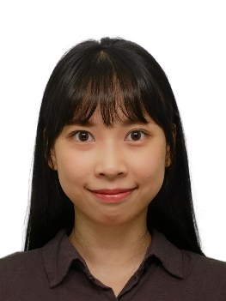**Tsai I-Hsiang**

**Address**

21F.-1, No. 2, Baoqing St., Xindian Dist., New Taipei City

**Birthday**

2000/12/03

[nooorika1203@gmail.com](mailto:nooorika1203@gmail.com) 0958066566

**Profile**

**Education**

2019/09~2023/06

Yuan Ze University

Department of Electrical Engineering

2023/09~2025/08

National Taiwan University of Science and Technology

Department of Electrical Engineering (Master Degree)

**License**

JLPT N1

TOEIC 640

**Skills**

Microsoft office

C++、MATLAB

**Thesis**

A Study on Blockchain Transaction Models with Priority

**Internship**

2021/07~2022/06

Keysight Technology

Calibration intern

**Autobiography**

I was born in Osaka, Japan, and raised as an only child. From an early age, I grew up in a bilingual environment where both Chinese and Japanese were spoken. However, since my life was mainly based in Taiwan, I had limited opportunities to use Japanese beyond conversations with family and friends. While I was able to speak the language, it was difficult to develop proficiency in reading and writing. To overcome this, I developed a habit of reading from a young age, gradually building my vocabulary and expressive skills. As a result, I was able to reach a level of Japanese proficiency comparable to that of a native speaker.

For my undergraduate studies, I majored in Electrical Engineering (Group B) at Yuan Ze University, with a focus on communications. Starting with fundamental courses in my first and second years, I moved on to more specialized subjects such as “Communication Systems” and “Digital Signals” in my third year. I became increasingly curious about how this knowledge is applied in real-world industries. To gain practical experience, I interned at Keysight Technologies Taiwan during my third year. This one-year internship allowed me to bridge academic theory with hands-on practice, develop problem-solving and analytical skills, and improve my professional abilities through interaction with experienced seniors.

My enriching undergraduate experience motivated me to pursue a master’s degree. Under the guidance of Professor Shung-Ping Chung at National Taiwan University of Science and Technology, I have been conducting research on queuing theory and applying it to blockchain models. By integrating theory with practice, I am currently working toward completing my master’s thesis, which I expect to finish in July—marking a perfect conclusion to my academic journey.

Beyond my academic pursuits, I actively participated in various group activities. I served as class representative for four academic years, vice president of the departmental student association, and vice chair of the freshman orientation camp. I also collaborated with students from other departments to plan and carry out various events. These experiences taught me how to lead a team, maintain a positive attitude in the face of challenges, and calmly manage crises while finding optimal solutions. I believe these qualities earned the trust of my professors and senior, who entrusted me with important responsibilities —responsibilities that I fulfilled to the best of my ability.

Throughout my studies, I have worked hard to balance academic and personal life, making my student years both fulfilling and vibrant. Looking ahead, I hope to maintain an optimistic outlook and face the unknown challenges of the future with courage and confidence.